**IBM Quantum Creative Challenge**

-Rajdip mondal

Hello reader! Welcome to my proposal for the Quantum Creative Challenge by IBM where the topic of discussion is to show that constructive quantum interference can produce correct results for a computation while a destructive interference can produce wrong results, basically nullify the computation to produce wrong results. So, let’s jump in.

First of all let’s discuss about a few terminologies that will be discussed throughout. Below given is a list of such terms:

1. Quantum computing

2. Qubits

3. Wave interference theory

4. Types of interference

5. Quantum interference

Let’s start the discussion:

**Quantum computing:** Quantum computing is the use of quantum phenomena such as superposition and entanglement to perform computation. A classical computer makes use of binary or binary-coded-decimal technology, where the smallest unit of memory that is a ‘bit’ is used to represent either of the 2 binary states i.e. 0 or 1 for computation one at a time. If a bit is 0 it represents ‘off’ state while a 1 represents ‘on’ state. Every information that we pass and get as an output in a classical computer is represented as a combination of this 0s and 1s. In a Quantum computer however, the smallest unit of computation is called a qubit. The difference between a bit and a qubit is that, while a bit represents either of absolute 0 or 1 state at a time, a qubit can have a transitional state(any state in between the boundaries of 0 and 1) by which it can convert itself to represent 0 or 1 as and when required. So, the possibilities of number of computations that can be performed using a qubit is theoretically in the class of 2^n(where n is number of computations). This is the actual benefit that a Quantum computation can offer. Pictorial representation of the difference between a classical bit and a qubit is given below:

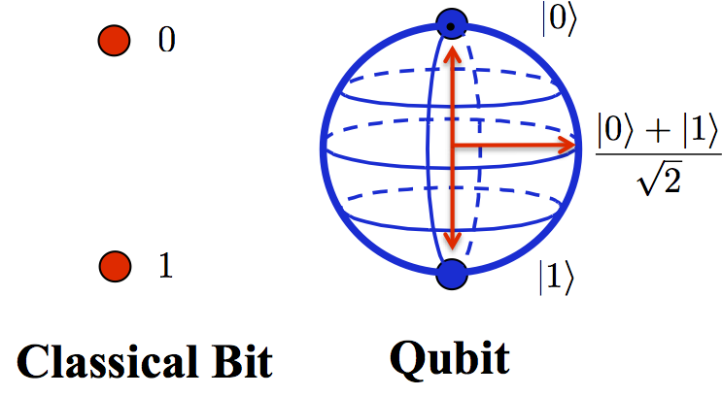

**Qubits:** A qubit or quantum bit is the quantum mechanical analogue of a classical ‘bit’. A qubit is a 2 state quantum-mechanical system. Below given is the pictorial representation of a qubit:

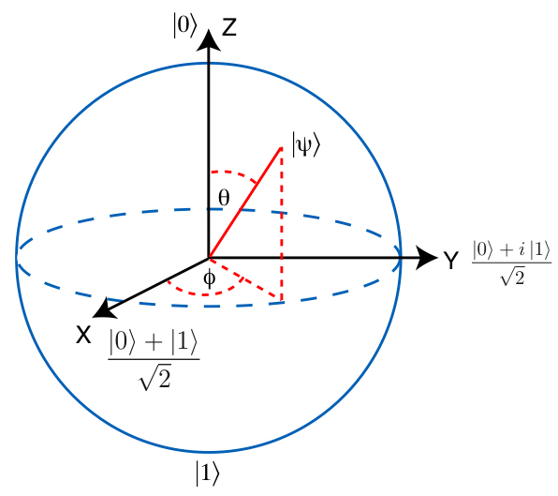

Here |0> state is analogue to binary state 0 and |1> is analogue to binary state 1. The arrows along x,y,z axis shows that rotation of this arrows can make a qubit represent any intermediate stage between 0 and 1.

**Wave interference theory:** A qubit, as a quantum molecule follows the basic laws of quantum physics like wave interference, Schrodinger’s equations. In order to measure very small distances it is often useful to employ wave interference. When two wave fields are superposed their wave crests may add up, such a condition is called constructive interference. While, a crest and a trough of two different waves encounter they tend to nullify each other (if of equal wavelength and amplitude), such a condition is called a destructive interference. Since, qubits can be considered as an individual quantum object, it is often said that “each particle interferences with itself”. Using the wave properties, it is possible to predict the probabilities for a certain outcome using the Schrodinger’s equation.

Below is the pictorial representation of a case of constructive interference and destructive interference:

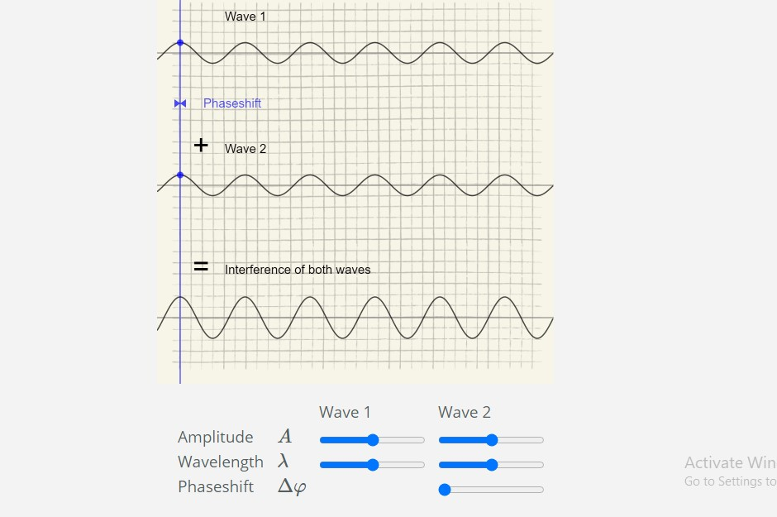As the phase shift and wavelength properties of the wave are same, it forms a constructive interference and the resultant wave is of combined amplitude of both waves.

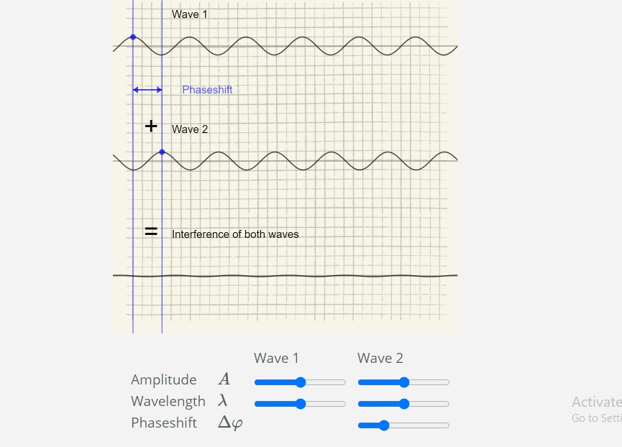

As the phase shift of both the waves are not same and is put in such a stage that the crest of wave 1 superposes with the trough of wave 2, both of almost equal amplitude, the resultant wave is almost of zero amplitude.

Let’s use Schrodinger’s equation:

iℏ∂∂tψ(r,t)=(−ℏ22mΔ+V(r,t))ψ(r,t)

All experiments so far have confirmed Born’s rule: the squared modulus |ψ|2 **of the state function** ψ represents the probability to find a quantum object at time t at position r with all other parameters contained in ψ. However, in quantum computing we use the term “probability cloud” instead of wave function probability.

**Types of interference:** A wave interference phenomena can be of 2 types: Constructive and destructive. We call an interference constructive when crests of two waves (same wavelength and phase shift) superpose with each other. On the other hand, a destructive interference is the one where, two waves superpose in such a way that crest of one coincides with trough of the other and the resultant wave has zero amplitude if the 2 waves are of equal amplitude.

On applying Schrodinger’s equation to resultant wave of constructive interference, we find that probability is nearly equal to 1, i.e. the computation by the qubit(s) will be correct. On applying Schrodinger’s equation to resultant wave of destructive interference, we find that probability is nearly equal to 0,i.e. the computation by the qubit(s) will be null or wrong.

**Quantum Interference:**

As discussed earlier quantum computing particles called qubits follow the principles of interference and Schrodinger’s equation for probability finding. Quantum interference is a by-product of superposition that allows us to bias the measurement of a qubit toward a desired state or set of states. However in case of practical quantum computing, we use “Twist gates”. The “twist gates” form an important class of gates parameterized by a parameter : 0<=(alpha)<=⫪| as follows:

T(alpha) := matrix(1 0 )|

1. e^(i.(alpha)))|

The gate shifts the phase of a quantum state by (alpha)| radians; in particular, it can be visualized as a rotation about the z-axis of the Bloch sphere representation of the qubit. Two twist gates are of particular historical relevance. The identity gate is defined as I:T(0)|. On the other hand, the so called “Z-gate” is the twist gate associated with (alpha)= ⫪| i.e. z:=T(⫪)|. The I|,X| and Z| linear operators belong to a special-family called the Pauli matrices.

Another fundamental single-qubit gate is the (2x2)|Hadamard matrix:

H☹1/root(2))*matrix(1 1)|

( 1 -1)|

This gate maps |0> -> (1,1)/root(2)| and |1> ->(1,-1)/root(2). In particular, upon measurement,

H|0>| and H|1>| have a 50-50 chance of being in the state 0| or 1|. The Hadamard gate is therefore useful to generate a uniform superposition of the measurement states. This gate is a common initialization step in many quantum algorithms.

From all this we can draw a conclusion using an analogy that :

1. When there is constructive interference, the the resultant wave amplitude amplifies and analogous to this in quantum computing, we can amplify the probability of correct answer.
2. Quantum interference in constructive interference leads to a quantum speed-up.
3. In case of destructive quantum interference, the probability of correct answer reduces to zero and we expect a wrong output.

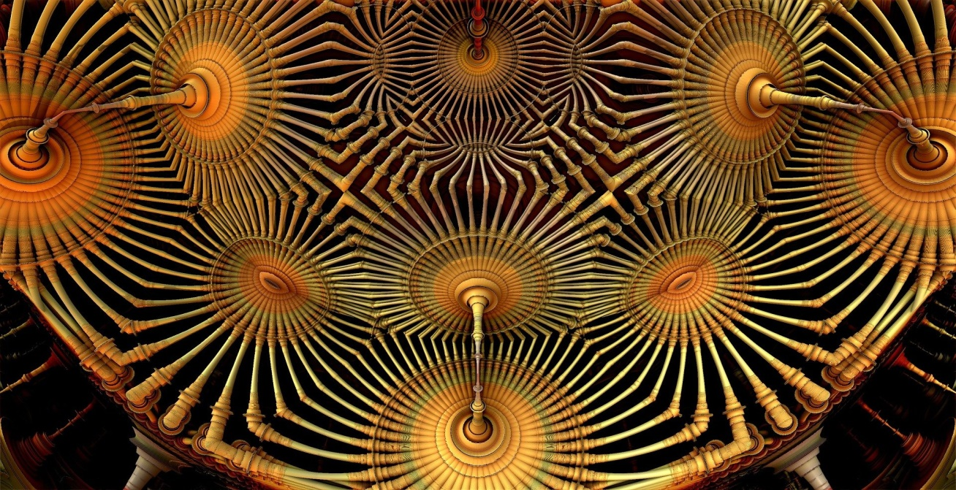

A pictorial representation of artificially depicted quantum interference.

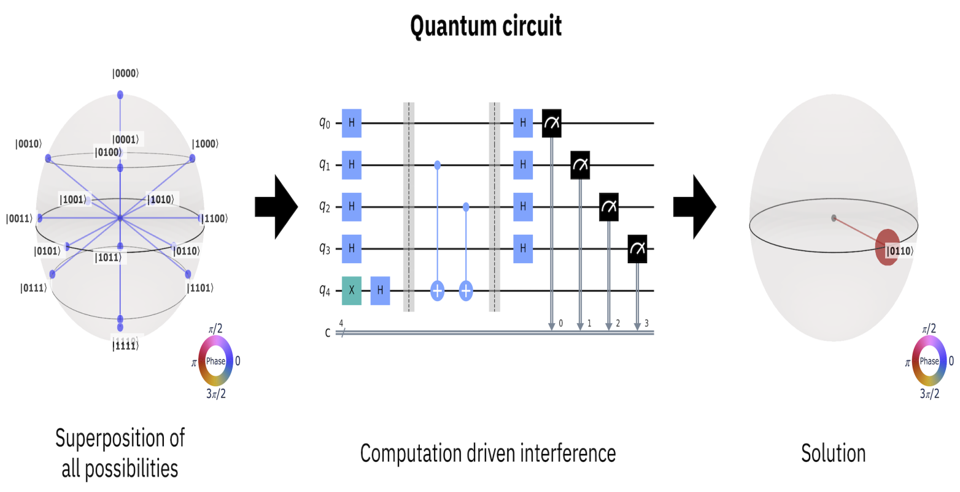

Working computation for quantum interefernce

---------------------------The end-------------------------------